M.S.P.ARTS,SCIENCE AND K.P.T. COMMERCE COLLEGE
MANORA DIST – WASHIM



Extension Activities Report
Theme-1 :-
How To Solve Mathematical Problem
‘Vedic Mathematics and Basic Mathematical Skills’
Theme - 2
“Remove the Fairness of Mathematical Problem from School Pupil”
ActivityBy
Department of Mathematics
2017-18

(To be submitted to the Principal)

----------------------------------------------------------------------------------------------------------------
www.mspkptmanora.ac.in

Affiliated to Sant Gadge Baba Amravati University, Amravati.

Contents
I Introduction
II. Activity Purpose
III. Main Theme
IV. Photos
V. Feedback and Recommendations
Annex I-List of Participants
Annex II- Feedback form

Introduction and Purpose of Extension Activities :-
We know that very well use of Mathematics in General life and back bone of science and most common use in all field .So, our activity is very innovative and creative for school level Pupil .The main purpose of activity are “ To remove faire about maths problem” and “Awareness and How to solve problem” Some students are very faired and some students has suicide for only reason exam failed like as 10th exam ,12th exam etc.
Our first target is that to remove faire .We will do aware to every pupil of school level of Manora Tahsil that Mathematics is an art and very simple ,very easy but not difficult and enjoy yourselves with mathematics .
‘Awareness of Mathematics & How to solve it’at School Level.
Students of our M. S. P. Arts, Science & K. P. T. Commerce college, Manora had gone to L. S. P. M. Highschool, Manora to teach under Extension Activity with permission of our principal Dr. N. S. Thakare sir.

Under this activity our students took some lessons on 9th and 10th std. In that lessons they cleared concepts of Algebra and Geometry. Our students explained this subjects as easy as possible. Along with these lessons they they also arranged a class to guide them.

During this class they observed that still some students of that school had fear of Mathematics. At such time, our students tried to find reasons behind their fear and after that they took some interesting activities to relief them from fear of Mathematics.

Our students told them some easier and interesting methods to solve Mathematical problems and hence they praised by Headmaster of L. S. P. M. Highschool, Dhamani Manora.

The proof of this activity is attached with this report issued from L. S. P. M. High school.
Under Graduate Students -
Firstly to aware of Mathematics in our society from Department of Mathematics M. S. P. College, Manora , our Departement will be take atleast 10 schools as well as highwer secondary schools at Manora Tahsil level.
Department will pepare four group from B. Sc. II and B.Sc III. These groups and Prof. Mahaveer Dhabe ( NET, JRF, SET) guided to school students and tell the technique about problems How to solve it.
This activity will be complete in near about 15 days and also department shall be tsken feedback forms froms each student and school teachers also.
Photo Gallary-
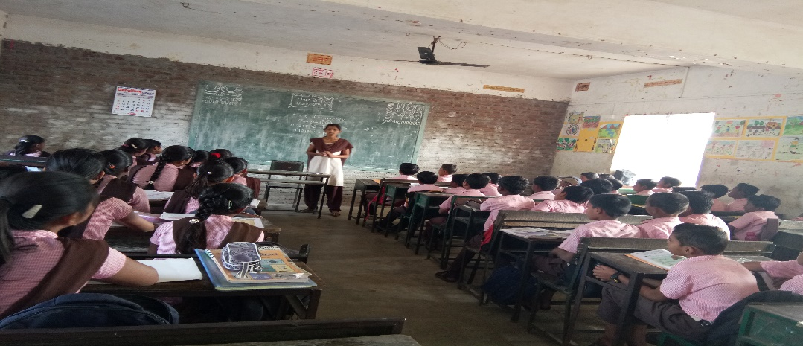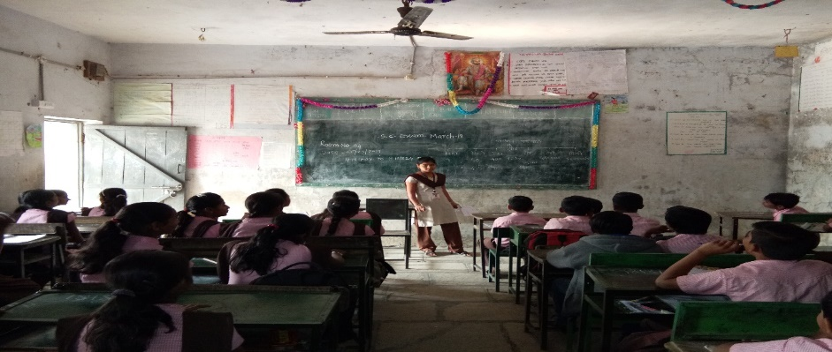
B.Sc – III students Miss. Vaishanvi Ingole and Priti Matre has teaches to Primary School and Inter. Date -: 15/03/2018
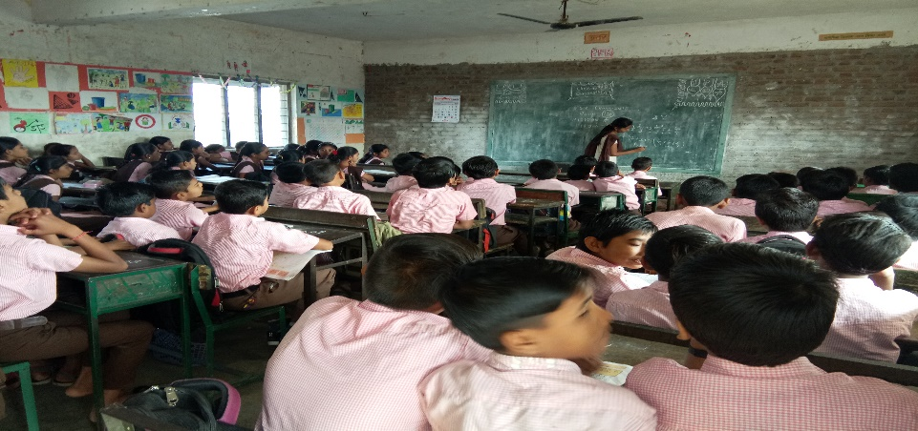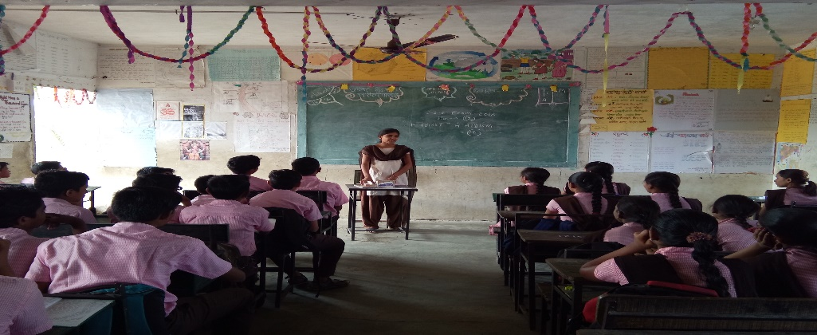

B.Sc – III students Miss. Pooja Ingole has teaches to Primary School and Inter. Date -: 15/03/2018

B.Sc –III Miss. Priti Matre Students has teaches to Primary School
Name – 1) Miss. Vaishnavi C. Ingole
2) Miss. Prapti Y.Kale
3) Miss Anuya U. Khupase
4) Miss. Priti M. Matre
5) Miss. Pooja M. Ing
6) Miss. Veena R. Rathod
Submitted By
Prof. Mahaveer C. Dhabe
Department of Mathematics

.

